**Project Design Phase-II**

**Data Flow Diagram & User Stories**

|  |  |
| --- | --- |
| Date | 4 November 2022 |
| Team ID | PNT2022TMID18163 |
| Project Name | Project - Industry specific intelligent fire management system |
| Maximum Marks | 4 Marks |

**Data Flow Diagrams:**

A Data Flow Diagram (DFD) is a traditional visual representation of the information flows within a system. A neat and clear DFD can depict the right amount of the system requirement graphically. It shows how data enters and leaves the system, what changes the information, and where data is stored.

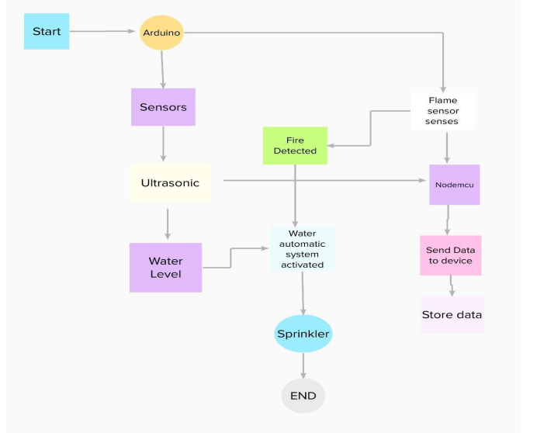

**User Stories**

Use the below template to list all the user stories for the product.

| **User Type** | **Functional Requirement (Epic)** | **User Story Number** | **User Story / Task** | **Acceptance criteria** | **Priority** | **Release** |
| --- | --- | --- | --- | --- | --- | --- |
| Customer (Mobile user) | Registration | USN-1 | As a user, I can get my temperature readings from the sensors | I can get temperature alert | High | Sprint-1 |
|  |  | USN-2 | As a user, I can enroll for the application by entering phone number | I can get to the website | Medium | Sprint-1 |
|  |  | USN-3 | As a user, I can monitor temperature variations | I can monitor temperature variations | High | Sprint-2 |
|  |  | USN-4 | As a user, at any point I get the temperature readings and fire alert | I get to know fire alert at any point | High | Sprint-1 |
|  | Login | USN-5 | As a user, I can log into my phone number | I can get to the website through my phone number | High | Sprint-1 |
|  | Interface | USN-6 | As a user, the connection must be quick and effectively open | I can access the website at any point without any problem | High | Sprint-1 |
| Customer (Web user) | Data Transmission | USN-7 | As a user, I can open the website and see the temperature changes | I can get to the information concerning temperature changes | HIgh | Sprint-1 |